Web Network Load Balancer
Design Document 2

Version 1.0



Supervisor Name: Mr Tanweer Arshad
Student Name: Faheemullah Memon
Student ID: MC070402736

Revision History

Date (dd/mm/yyyy) | Version | Description | Author
5/12/2012 | 0.1 | Initial draft | Mc070402736
10/12/2012 | 1.0 | Finished and reviewed | Mc070402736

Table of Contents
Revision History 2
1. Introduction 4
2. Class Diagram 4
2.1. Network Load Balancer Library 4
2.1.1. Library Level Classes 5
2.1.2. Application Namespace 5
2.2.3. Routers Namespace 6
2.2.4. Servers Namespace 6
2.2. Configuration Console 7
2.2.1. Library Level Namespace 8
2.2.2. Controllers 8
2.2.3. Models 9
3. Database Design 11
4. Interface Design 12
4.1. Login Page 12
4.2. Dashboard 13
4.3. Add or Update Server 14
4.4. Delete Server 15
4.5. Add or Update Application 16
4.6. Delete Application 17
4.7. View Traffic Details 18
4.8. Change Password 19
4.9. About Software 20
5. Deployment Diagram 21
5.1. Deployment Instructions 21
6. Test Cases 22

1. Introduction

In this document we will take a deeper look at the design of web-based network load balancing software. Following sections will create technical models and diagrams of the project that provide a peek into the internal machinery; cogs, joints, and levers. The documents also contain screen shots of the working software. These screen shot provide visual design of the system. In the end we have test cases with test description and results from the unit and regression testing.

2. Class Diagram

Class diagram have been split in to multiple sections to fit into this space. These are split based on container module and then namespaces inside them. For a single diagram, please see separate image document file in the documents packet.

2.1. Network Load Balancer Library
Networking load balancer code has been combined into a single .NET assembly. It makes it easier to attach any configuration interface to it and provides the decoupling and separation of concern. Most of this library is geared towards high performance and multi-threading.

2.1.1. Library Level Classes
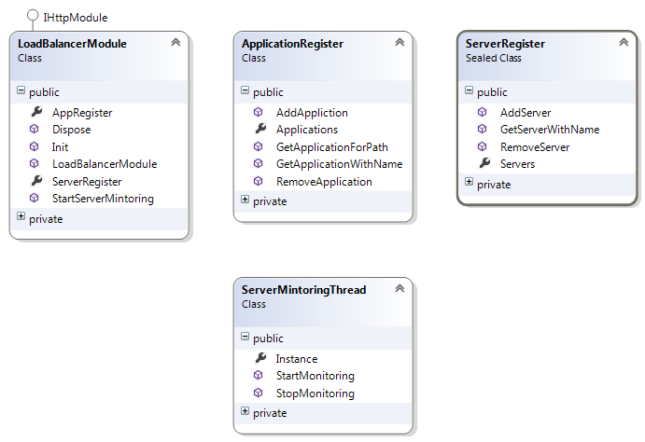
Package level classes control the lifecycle of the module and provide configuration and reporting access to external interfaces.

2.1.2. Application Namespace
Application package holds application related meta-data. It also contains the configured router and server pool information.
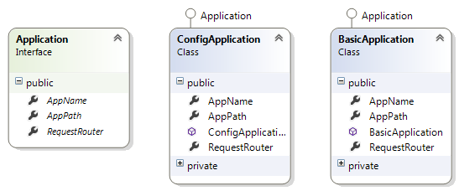

2.2.3. Routers Namespace
This is where all the magic happens. All different routing algorithms are implemented using these classes and supplements.
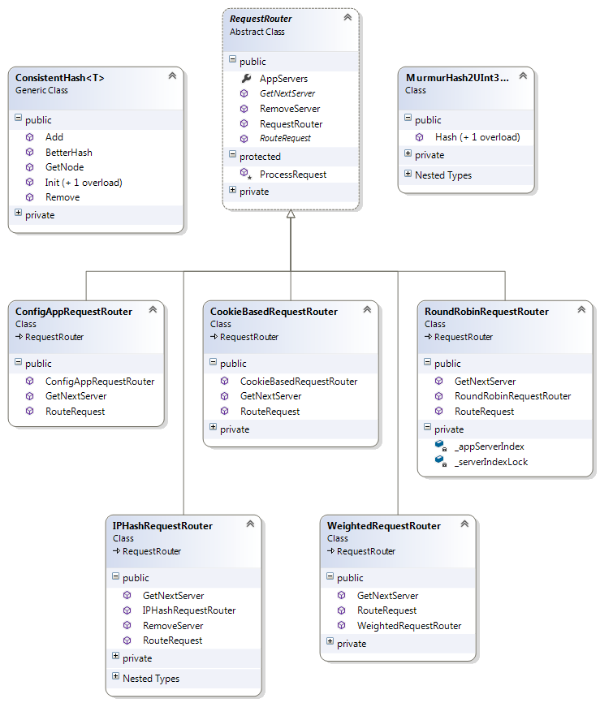

2.2.4. Servers Namespace
This namespace contains server meta-data and request processing functionality.
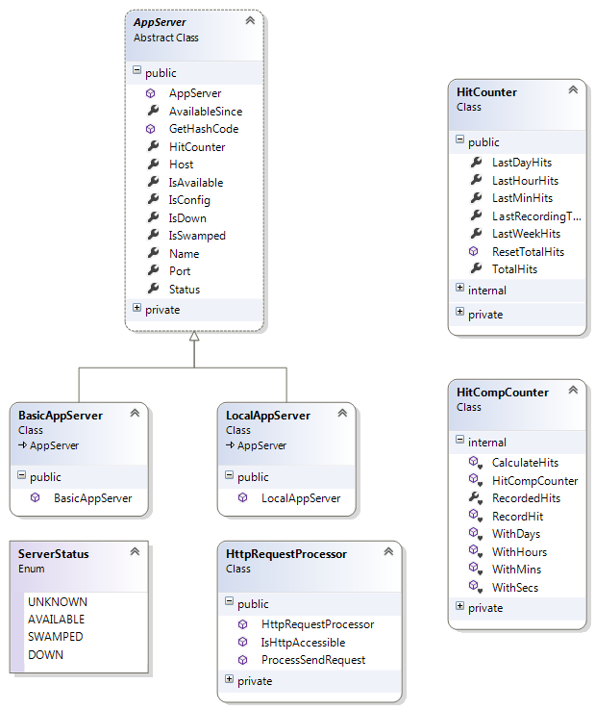

2.2. Configuration Console
Console is an ASP.NET MVC 4 web application that uses model view-view model design. View model design suggests putting business logic in specialized view classes called view models. Often database models are transformed and validated inside controllers in typical model-view-architecture and thus creates a lot of clutter and confusion. By creating specialized view models we make sure some of the business logic is moved into these classes. Controller still executes some of the business logic that has more dependencies.
Class diagrams are split into namespaces to fit in the space and increase readability. Separate image containing complete classes is also available in the documents packet.

2.2.1. Library Level Namespace

This namespace contains high level configuration, including web application life cycle and rudimentary configuration.
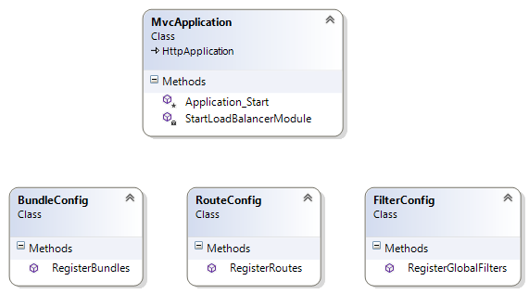

2.2.2. Controllers

Controllers contain core business logic beyond view models. They are the executors of all the logic. We have used different techniques for messaging between objects across namespaces and assemblies like singletons and argument passing. However, in console application we have also used Unity, a part of Microsoft enterprise library for inversion of control or IoC. Unity provides access to centralized multi-threaded object of network load balancer (NLB) library. It also provide much needed separation of concern and increases code testability.
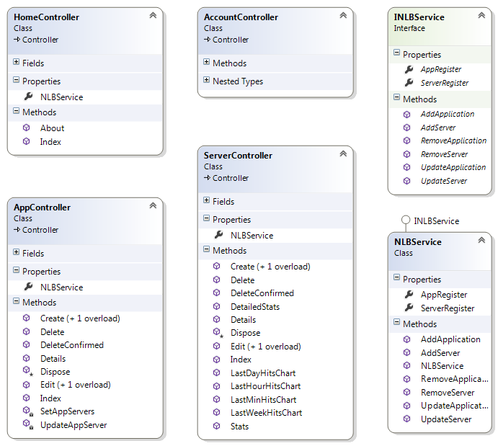

2.2.3. Models
Models namespace contains all models and view models used throughout the application. Some of business logic regarding validation is also distributed across these model classes.
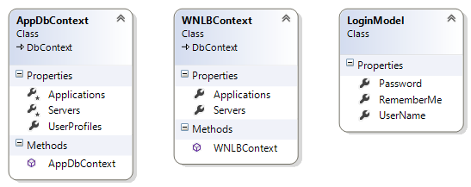
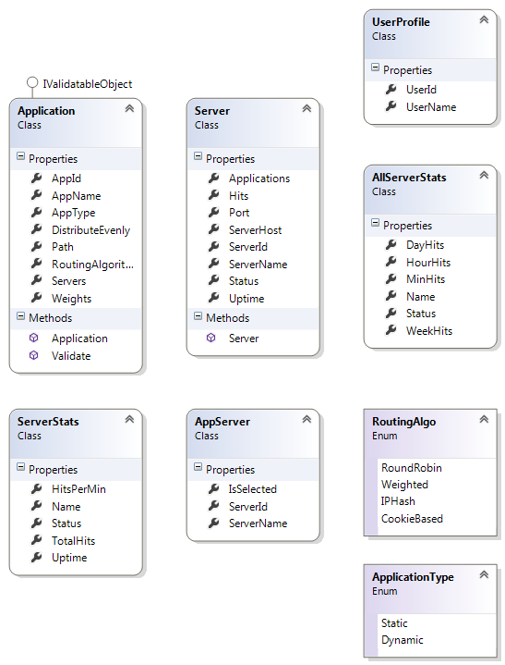

3. Database Design
Application uses a simple database only to store user membership information and application server meta-data information. There is a many-to-many relationship between application and server which is bridged by an extra table. Multiple applications can point to same server and an application can point to several servers.
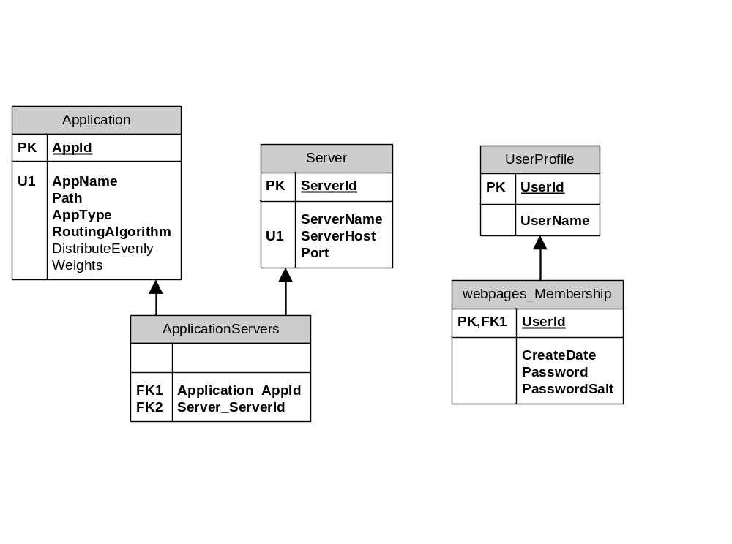

4. Interface Design

4.1. Login Page
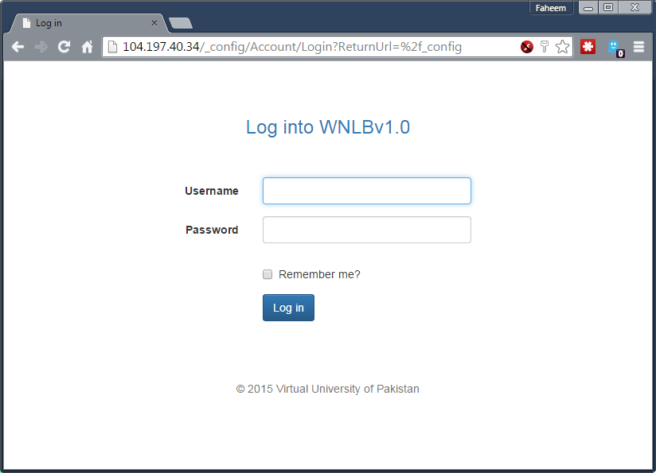

4.2. Dashboard
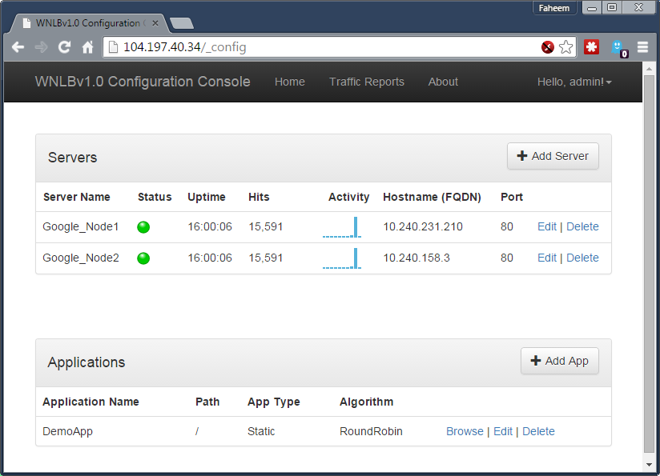

4.3. Add or Update Server
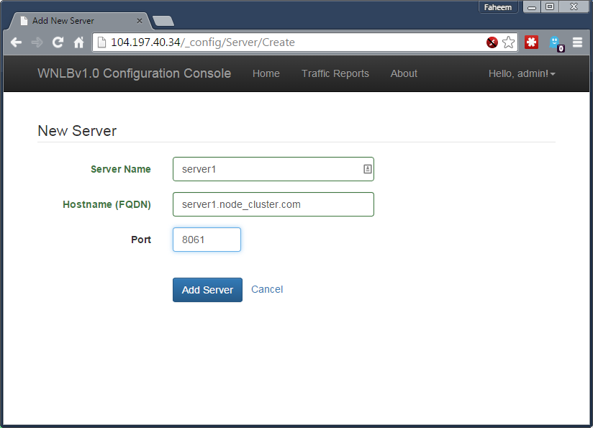

4.4. Delete Server
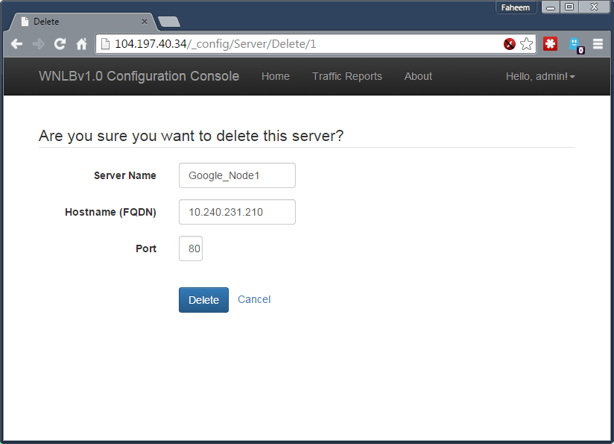

4.5. Add or Update Application
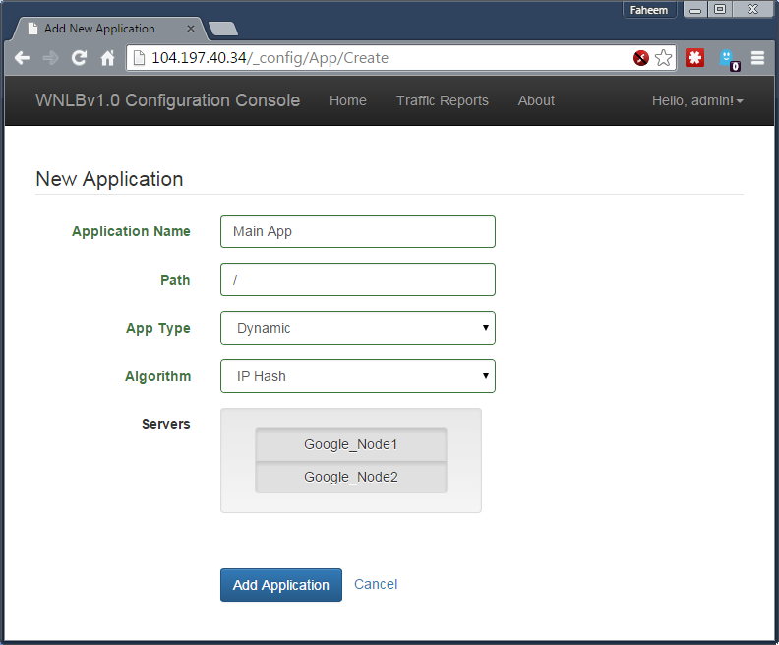

4.6. Delete Application
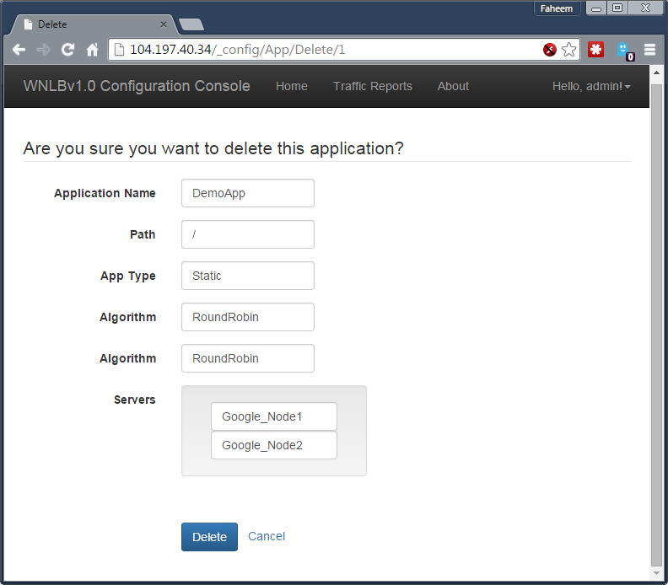

4.7. View Traffic Details
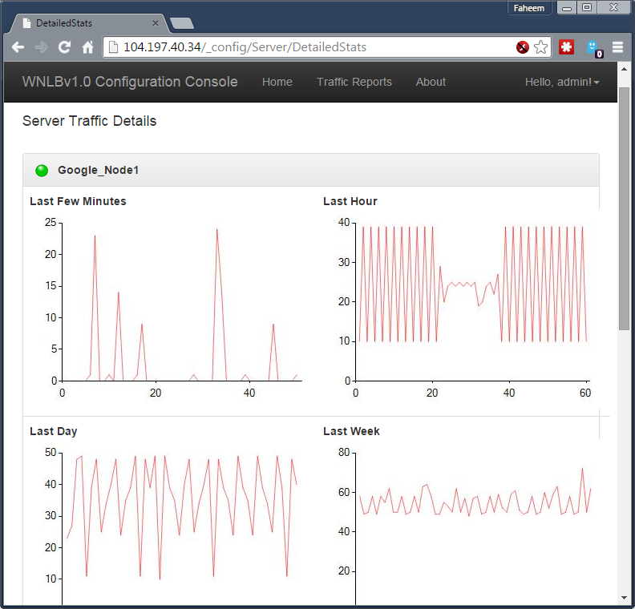

4.8. Change Password
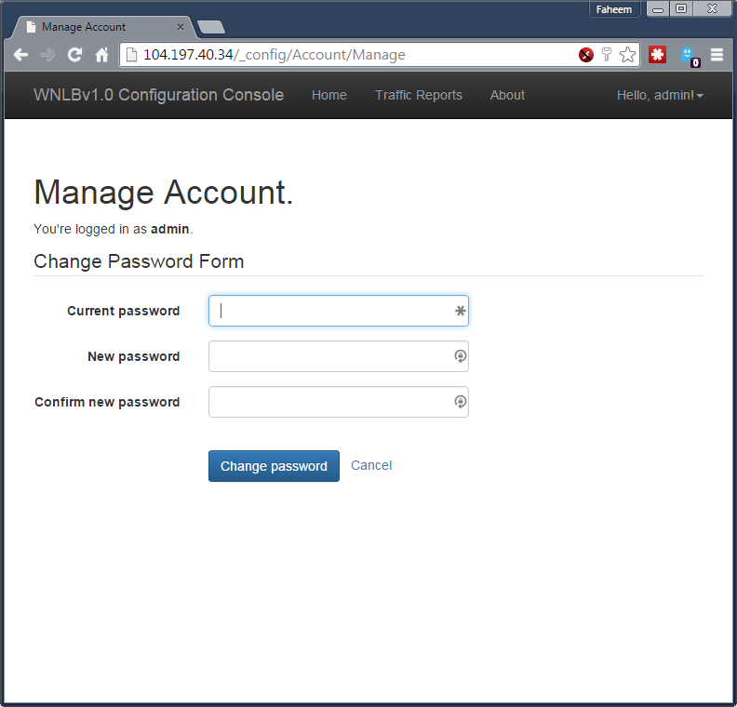

4.9. About Software
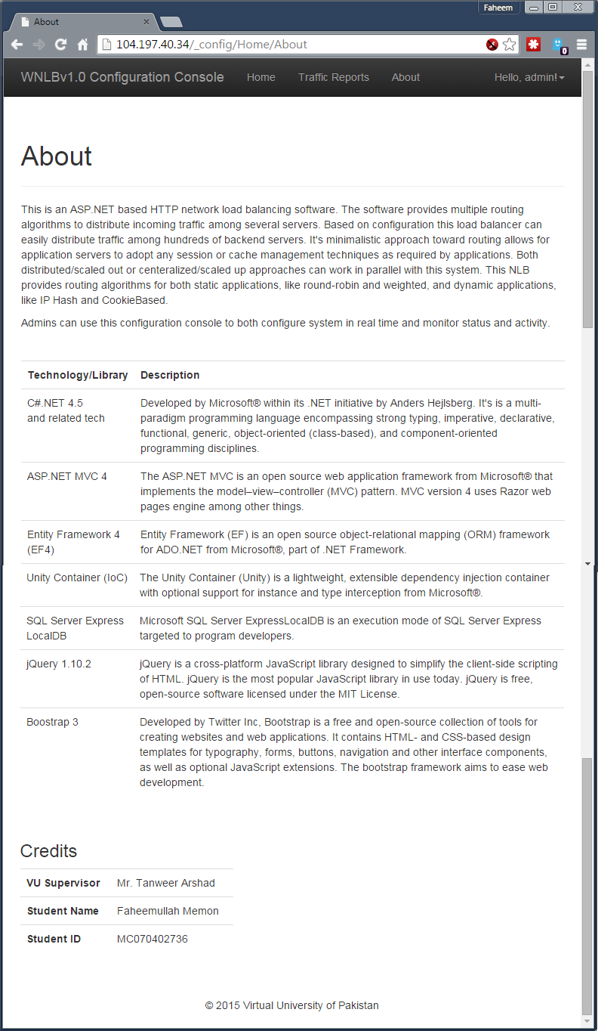

5. Deployment Diagram

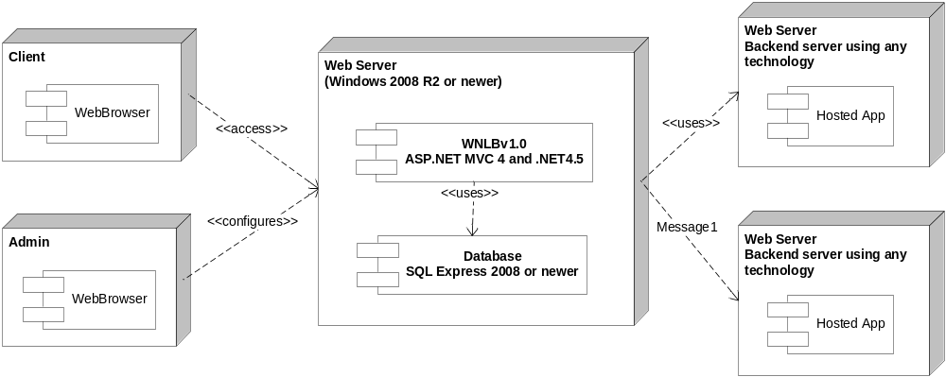

5.1. Deployment Instructions
System requires a Windows 2008 server with .NET 4.5 and MVC 4 runtime installed on it. Software runs on top of a Microsoft Internet Information Server. In addition to software setup, system also requires a MSSQL based database. Database can be a separate SQL Server instance, a SQL Express instance or a SQL LocalDB instance.
Backend web servers can run on any platform. They can be PHP, Java, ColdFusion, Rails or whatever. They only have to serve the HTTP protocol application on same path as registered with WNLB server.

6. Test Cases
# | Use Case | Test Case | Status
01-01 | 01 | Purpose: Check validation on input fields  Pre-conditions:  - System installed and running  - User not logged in before ore cookies have be cleared for domain  Test Data: Try empty values and dummy values  Steps:  - Browse to config console with no prior cookies  - System should display a login screen  - Enter test data in login screen and submit  - System should present validation errors with no spelling errors | Pass
01-02 | 01 | Purpose: Test login functionality  Pre-conditions:  - System installed and running  - User not logged in before ore cookies have be cleared for domain  Test Data: Try proper user information  Steps:  - Browse to config console  - System should present a login form  - Enter correct login information in the form and hit “Login” button.  - System should log user in successfully and load administration dashboard | Pass
02-01 | 02 | Purpose: Check input validation and input verification  Pre-conditions:  - System installed and running  - Admin is logged in to the system  Test Data: Try with empty values, in-correct old password, and bad change and confirm password values.  Steps:  - Open change password page from dashboard.  - Enter different data sets from test data.  - System should not change password and should present proper validation and verification error messages. | Partial Pass
02-02 | 02 | Purpose: Test password change functionality  Pre-conditions:  - System installed and running  - Admin is logged into the system.  Test Data: Try correct values and proper new password  Steps:  - Open change password page from dashboard.  - Enter correct old password and valid new and confirm password entries  - Submit form and systems should provide a password change confirmation.  - Logout of the system.  - System should accept changed password only. | Pass
03-01 | 03 | Purpose: Test input validation in add server page  Pre-conditions:  - System installed and running  - Admin is logged into the configuration console  Test Data: Try empty, incorrect, and too long inputs for server and port fields  Steps:  - Choose add new sever action from dashboard.  - Enter incorrect data as suggested in test data.  - System should present proper validation error messages. | Passed
03-02 | 03 | Purpose: Test add server functionality  Pre-conditions:  - System installed and running  - Admin is logged into the configuration console  Test Data: Enter proper values  Steps:  - Select add server action from console  - System should present an add server form.  - Enter proper values in the input fields and try to save the entry.  - System should add the server and start showing status of the server | Pass
04-01 | 04 | Purpose: Test update functionality  Pre-conditions:  - System installed and running  - Admin is logged into the configuration console  - A server entry exists in the system  Test Data: Enter proper information in the edit server form.  Steps:  - Choose update server action against a server record from server stats screen  - Enter correct values and try to update the server record  - System should reflect changes immediately and start routing traffic to newly entered server. | Pass
04-02 | 04 | Purpose: Test cancel update functionality  Pre-conditions:  - System installed and running  - Admin is logged into the configuration console  - A server entry exists in the system  Test Data: Dummy but proper data  Steps:  - Choose update server action against a server record from server stats screen.  - Enter proper but dummy data in the input fields  - Select cancel instead of primary call of action  - System should ignore changes and should not reflect it anymore. | Pass
05-01 | 05 | Purpose: Test delete server functionality  Pre-conditions:  - System installed and running  - Admin is logged into the configuration console  - A server entry exists in the system  Test Data: N/A  Steps:  - Choose delete action against a working server entry  - System should present a confirmation message  - Confirm and delete the record  - System should immediate take the server out of the pool and redirect all traffic to other server smoothly. | Pass
05-02 | 05 | Purpose: Test cancel delete functionality  Pre-conditions:  - System installed and running  - Admin is logged into the configuration console  - A server entry exists in the system  Test Data: N/A  Steps:  - Choose delete action against a server record from server stats screen  - System should present a confirmation message  - On confirmation screen, choose cancellation.  - System should ignore deletion operation | Pass
06-01 | 06 | Purpose: Check server pool listing and status  Pre-conditions:  - System installed and running  - Admin is logged into the configuration console  - One or more server entries exists in the system  Test Data: N/A  Steps:  - After a successful login, system should present a dashboard  - There should be a section of live server stats available in the dashboard  - System should provide live stats of server availability, request served counts, uptime, and action operations.  - Make one of the back end server unavailable behind the scene.  - Systems should reflect server down status and re-route traffic to other servers in the pool | Pass
07-01 | 07 | Purpose: Test validation and verification on add application form  Pre-conditions:  - System installed and running  - Admin is logged into the configuration console  Test Data: Entry empty, incorrect, and too long inputs.  Steps:  - Choose add application option from dashboard.  - System should present a meta data form to add application  - Enter empty, incorrect, and too long values in input fields.  - System should present proper validation error messages | Pass
07-02 | 07 | Purpose: Test add application functionality  Pre-conditions:  - System installed and running  - Admin is logged into the configuration console  Test Data: Enter proper values  Steps:  - Choose add application option from dashboard  - System should present a application meta data form  - Enter correct values in the form and try to save the application  - System should save the entry and start accepting incoming traffic for that application. | Pass
08-01 | 08 | Purpose: Test update application functionality  Pre-conditions:  - System installed and running  - Admin is logged into the configuration console  - An application record already exists in the system  Test Data: Enter proper values  Steps:  - Choose edit option against an application entry from dashboard  - System should display an update form.  - Enter updated values and submit the form.  - System should immediately apply changes and accept traffic with the updates. | Pass
08-02 | 08 | Purpose: Test update cancellation for applications  Pre-conditions:  - System installed and running  - Admin is logged into the configuration console  - Application record already exists  Test Data: N/A  Steps:  - Choose edit option against an application record  - System should present and update form with information loaded for that record.  - Change entries with proper values  - Instead of saving, choose cancel operation.  - System should ignore all changes and do not apply any change in the system configuration. | Pass
09-01 | 09 | Purpose: Test delete application functionality  Pre-conditions:  - System installed and running  - Admin is logged into the configuration console  - An application record exists  Test Data: N/A  Steps:  - Choose delete option against an application entry from dashboard  - System should provide a confirmation message  - Select confirm on the conformation page  - System should delete that entry and immediately stop serving requests on that path. | Pass
09-02 | 09 | Purpose: Test cancel deletion for application  Pre-conditions:  - System installed and running  - Admin is logged into the configuration console  - An application entry exists in the system  Test Data: N/A  Steps:  - Choose delete option on the dashboard against an application entry  - System should present a confirmation message  - On the confirmation screen, choose cancel option.  - System should ignore deletion operation and do nothing to existing configuration. | Pass
10-01 | 10 | Purpose: Test application listing  Pre-conditions:  - System installed and running  - Admin is logged into the configuration console  - On or more application records should exist  Test Data: N/A  Steps:  - After a successful login, system should present a configuration and monitoring dashboard.  - There should be a section on dashboard that lists all active applications.  - System should also present browse, edit, and delete options for these application entries. | Pass
11-01 | 11 | Purpose: Test server traffic graphs  Pre-conditions:  - System installed and running  - Admin is logged into the configuration console  - There should be one or more applications and servers configured and active in the system.  Test Data: N/A  Steps:  - Select traffic details option from dashboard  - System should present most resent hourly, daily, and weekly traffic graphics | Pass
12-01 | 12 | Purpose: Test routing functionality  Pre-conditions:  - System installed and running  - Admin is logged into the configuration console  - There should one or more application and server entries in the system.  - The backend servers should be available to server requests  Test Data: N/A  Steps:  - Browse application path on load balancer server  - System should route traffic according to selected routing algorithm  - Verify traffic split by looking at request headers  - Verify traffic splits by looking at server stats in configuration console  - Take a server down and bring it back up. System should still work smoothly.  - Traffic should be processed faster | Pass
12-02 | 12 | Purpose: Test round-robin routing functionality  Pre-conditions:  - System installed and running  - Admin is logged into the configuration console  - There should one or more application and server entries in the system.  - The backend servers should be available to server requests  Test Data: N/A  Steps:  - Make sure the test application is using round-robin algorithm.  - Browse the application URL on load balancer server  - System should present the hosted application.  - Investigate server headers to make sure requests are split evenly between servers in the pool  - Take a server down and bring it back up. System should still work smoothly.  - Traffic should be processed faster | Pass
12-03 | 12 | Purpose: Test weighted routing functionality  Pre-conditions:  - System installed and running  - Admin is logged into the configuration console  - There should one or more application and server entries in the system.  - The backend servers should be available to server requests  Test Data: N/A  Steps:  - Make sure the test application is using round-robin algorithm.  - Browse the application URL on load balancer server  - System should present the hosted application.  - Investigate server headers to make sure requests are split correctly between servers in the pool  - Take a server down and bring it back up. System should still work smoothly.  - Traffic should be processed faster | Pass
12-04 | 12 | Purpose: Test IP-Hash routing functionality  Pre-conditions:  - System installed and running  - Admin is logged into the configuration console  - There should one or more application and server entries in the system.  - The backend servers should be available to server requests  Test Data: N/A  Steps:  - Make sure the test application is using round-robin algorithm.  - Browse the application URL on load balancer server  - System should present the hosted application.  - Investigate server headers to make sure requests are split correctly between servers in the pool  - Take a server down and bring it back up. System should still work smoothly.  - Traffic should be processed faster | Pass
12-05 | 12 | Purpose: Test cookie based routing functionality  Pre-conditions:  - System installed and running  - Admin is logged into the configuration console  - There should one or more application and server entries in the system.  - The backend servers should be available to server requests  Test Data: N/A  Steps:  - Make sure the test application is using round-robin algorithm.  - Browse the application URL on load balancer server  - System should present the hosted application.  - Investigate server headers to make sure requests are split correctly between servers in the pool  - Take a server down and bring it back up. System should still work smoothly.  - Traffic should be processed faster | Pass
13-01 | 13 | Purpose: Test session based routing functionality  Pre-conditions:  - System installed and running  - Admin is logged into the configuration console  - There should one or more application and server entries in the system.  - The backend servers should be available to server requests  Test Data: N/A  Steps:  - Make sure there is a dynamic application in the system and IP-Hash or Cookie based routing algorithm is selected.  - Brose the application path on load balancer  - Load balancer should load hosted application home page  - Login in the hosted application and try check out several pages  - System should persist the session and work smoothly  - Verify system headers and cookies to make sure system is tracking session users correctly | Pass
14-01 | 14 | Purpose: Test configuration persistence functionality  Pre-conditions:  - System installed and running  - Admin is logged into the configuration console  Test Data: N/A  Steps:  - Try to add a server or application in the system.  - Take whole system down and then back up.  - System should still persist all inputs from previous session | Pass

